GRANARD MUNICIPAL DISTRICT

Corporate Affairs,
Aras an Chontae,
LONGFOIRT.

17th January 2017.

To: Each Member of Granard Municipal District.

Dear Member,

You are requested to attend Meeting of Granard Municipal District to be held in
Granard Community Library on Tuesday, 24th January 2017 at 3.30 p.m. to transact business, as set out on the Agenda hereunder.

Yours sincerely,
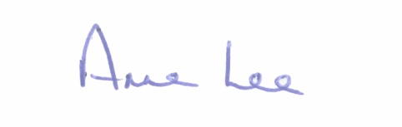

_______________
Anne Lee,
Meetings Administrator.

AGENDA

Prayer before meeting.

1. Confirmation of Minutes of the following meetings of Granard Municipal District held on the 22nd November 2016-

- Committee Meeting.
- Municipal District Meeting.
- copies enclosed.

2. Matters arising from Minutes.

3. Election of Leas Cathaoirleach.

4. Presentation in relation to the roll-out of the Rural Development Programme 2014- 2020 (LEADER)- Mr. Adrian Greene, CEO of Longford Community Resources clg.

5. Consideration and adoption of Draft Municipal District Report for inclusion in Longford County Council 2016 Annual report – draft enclosed.

6. Area Engineer’s Progress Report.

7. Consideration of request from Corporate Policy Group that each Municipal District nominate a town in their district to pilot a Town Team Initiative.

8. Consideration of Taking in Charge of the following Housing Estates -
- Bothari na gCarraige Ballinalee.
- Mastersons Close, Abbeylara.
- Woodland Park, Cullyfad.
- details attached.

9. Notices of Motions submitted by Councillors, as listed hereunder -

Councillor Michael Carrigy.

“I call on Longford County Council to extend the public lighting on the Bracklin Road, Edgeworthtown as far as the entrance to Chestnut View.”

“I call on Longford County Council to apply for funding to install a play area at the Sports Field in Lisryan.”

“I call on Longford County Council to apply for a Low Cost Safety Scheme at the Ballymore GAA Grounds in Ballybrien, Granard.”

10. Correspondence.
(a) Correspondence dated 12th January 2017 received from An Garda Siochana in relation to the provision of a Garda Superintendent in the Granard district.
(b) Correspondence dated 12th January 2017 received from Bus Eireann regarding safety issues at school bus stops.

11. A.O.B.

